PROJECT REPORT
(Project Term January-May 2021)

Personality Prediction System through CV Analysis

Submitted by :
Yaswant aditya 11902268

Course code : INT246

Under the Guidence of
Dr. Sagar Pandae


DECLARATION
I hereby declare that the project work entitled (“Personality Prediction System via CV analysis”) is an authentic record of my own work carried out as requirements of Project for the award of B.Tech degree in CSE from Lovely Professional University, Phagwara, under the guidance of Dr. Sagar Pande during August to November 2020. All the information furnished in this project report is based on our own intensive work and is genuine.

Name of Student : yaswant aditya
Registration Number: 11902268
Yaswant aditya
(Signature of Student 1)

Date: 20-11-2021

CERTIFICATE
This is to certify that the declaration statement made by this group of students is correct to the best of my knowledge and belief. They have completed this Project under my guidance and supervision. The present work is the result of their original investigation, effort and study. No part of the work has ever been submitted for any other degree at any University. The Project is fit for the submission and partial fulfillment of the conditions for the award of B.Tech degree in CSE from Lovely Professional University, Phagwara.

Signature and Name of the Mentor

School of Computer Science and Engineering,
Lovely Professional University,
Phagwara, Punjab.

Date : 20-112021

Table of Content

- Introduction
- Problem Statement
- Problem Analysis
- Software Requirement Analysis
- Design
- Implementation
- Bibliography

1. INTRODUCTION

The word ‘Personality’ derives from the Latin word persona which refers to a mask worn by actors to act. However, Personality is much more than a mask now, it could possibly determine whether a person is suitable for a particular job profile. It tells us if a human is capable enough to lead, influence and communicate effectively with others. The first step of recruitment is the job application which consists of personal details, experience, and most importantly CV. Companies typically receive thousands of applications per job opening and have a dedicated team ofscreeners to select qualified candidates. It is very difficult for human beings to manually go through the CV of all applicants. Many candidates get filtered out in the first round itself on the basis of suitability, improper CV, not being skilled enough. Hiring the rightcandidate is a very difficult task as no candidate is perfect, some might not be skilled enough or some might not have the right personality. Hence, we propose a way in which the process of shortlisting gets streamlined and faster by personality prediction. CV’s can reflect upon the professional qualifications of a person but do not reflect upon the personality of a person. Personality is one of the vital factors which suggests how a person would be able to work in a designated role, hence personality analysis and understanding is key. Our objective doing this project is to make the machine more human, and analyse the candidate in such a way that an actual human reviewer would.
1.1Project Objectives
The objectives of the project are as stated below:
• To develop a system to provide a more effective way of short-listing the candidates.
• To determine the key skill characteristic by defining each expert’s preferences and ranking decisions.
• To automate the process of requirement specifications and applicant’s ranking. • To conduct online aptitude and personality test.
• To produce ranking decisions that would have relatively higher consistency than those of human experts.

2. Problem Statement
There is a huge workload on the human resource department to select the right candidate for a particular job profile which in turn would provide experts workforce for the organization from a large pool of candidates.

2.1 Objective :-
This system can be used in many business parts/areas that may require expert candidates. This system will reduce the workload of the (workers in general/hiring, training, and firing department). This system will help the (related to workers in general) to select the right candidate for the desired job profile, which in turn provide the expert (all the workers in a company or country) for the organization. Admin can easily shortlist a candidate based on their personality scores and select the appropriate candidate for a particular job profile. Using Natural Language Processing (NLP) can be defined as a process that enables a machine to become more like a human, because of this deeply cutting the distance between machines and humans. This system will focus not only on qualification and inexperience but also focuses on other important aspects, which are needed/demanded for a particular job position. Admin can store the data in excel sheet for further comparison and sorting of data.
The project is based on identifying the personality of an individual using machine learning algorithms and big 5 models. The personality of a human plays a major role in his personal and professional life. Now a days, many organizations have also started shortlisling the candidates bassed on their personality as this increase the efficiency of the work because the person is working in what he is good at than what he is forced to do.

3. Problem Analysis :-
Personality prediction is to scientifically finding out, appraising and comprehending an individual’s personality based on CV. In this paper, an automated personality prediction system through CV is presented, which classifies the personality traits as well as profession of an individual naturally with the assistance of a PC framework, without the human intercession in which sets of characters to identify the personality traits related to a person, which helps in choosing the profession of that individual.

3.1 Problem definition And what new in the System :-
The proposed system is two sided: it would be candidate oriented or organization oriented. In the first case the system would recommend the candidate a list of jobs that better fits his skills.
In the second scenario, the recruiter would publish the specifications specification and requirements of available job positions and the candidates can apply for the same by submitting their CVs. The existing e-recruitment system simply scans the submitted CVs and shortlist the candidates wherein the proposed system conducts an online aptitude test and personality test thereby predicting the personality of the candidate as well as short-listing the candidate based on his skills and decision-making ability.

4. Software Requirement Analysis :-
- Central Processing Unit (CPU) — Intel Core i5 6th Generation processor or higher. An AMD equivalent processor will also be optimal.
- RAM — 8 GB minimum, 16 GB or higher is recommended.
- Graphics Processing Unit (GPU) — NVIDIA GeForce GTX 960 or higher. AMD GPUs are not able to perform deep learning regardless. For more information on NVIDIA GPUs for deep learning please visit https://developer.nvidia.com/cuda-gpus.
- Operating System — Ubuntu or Microsoft Windows 10. I recommend updating Windows 10 to the latest version before proceeding forward.

4.1 DEPENDENCIES OF SYSTEM :-
Python Modules/Libraries:
1. OS: For accessing the files and data from internal storage.
2. Pandas: For accessing and manipulating datasheets.
3. Numpy: For working on arrays and other data manipulation.
4. Tkinter: For building the GUI.
5. Functools: Tools for Manipulating Functions. Purpose: Functions that operate on other functions.
6. Pyresparser: Module for extracting information from resume.
7. Sklearn: It features various classification, regression and clustering algorithms. We used sklearn to make the model learn on various characteristic values using logical regression.
5. Design :-
The objective of our paper is to predict the personalityof a person based on their score of openness, extraversion agreeableness, neuroticism and conscientiousness. For achieving this, we needed a way to calculate the scores directly from every CV. Ourapproach as shown in Fig.1 was to parse the entire resume and search for keywords relating to the ‘Big Five Test’. Fig-1: - Workflow of Proposed System For parsing CVs, we have used pyresparser- a simple resume parser used for extracting important features such as name, email id, description, skills from CVs. Pyresparser supports PDF and DOCx files. The parsed data is then stored in a CSV file.
Cv dataset
parsing
Personality score

Personality type
Prediction using ML

For parsing CVs, we have used pyresparser- a simple resume parser used for extracting important features such as name, email id, description, skills from CVs. Pyresparser supports PDF and DOCx files. The parsed data is then stored in a CSV file.
- Implementation :-
6.1 BACKGROUND OF PERSONALITY PERCEPTION
The Big Five Personality Traits model is based on findings from several independent researchers, and it dates back to the late 1950s. But the model as we know it now began to take shape in the 1990s. Lewis Goldberg, a researcher at the Oregon Research Institute, is credited with naming the model "The Big Five." It is now considered to be an accurate and respected personality scale, which is routinely used by businesses and in psychological research. The Big Five Personality Traits Model measures five key dimensions of people's personalities: Openness: sometimes called "Intellect" or "Imagination," this measures your level of creativity, and your desire for knowledge and new experiences. Conscientiousness: this looks at the level of care that you take in your life and work. If you score highly in conscientiousness, you'll likely be organized and thorough, and know how to make plans and follow them through. If you score low, you'll likely be lax and disorganized. Extraversion/Introversion: this dimension measures your level of sociability. Are you outgoing or quiet, for instance? Do you draw energy from a crowd, or do you find it difficult to work and communicate with other people? Agreeableness: this dimension measures how well you get on with other people. Are you considerate, helpful and willing to compromise? Or do you tend to put your needs before others'? Natural Reactions: sometimes called "Emotional Stability" or "Neuroticism," this measure emotional reactions. Do you react negatively or calmly to bad news? Do you worry obsessively about small details, or are you relaxed in stressful situations?

  - Implementation of Project :-
train_model class: It contains two method which train the model and predict the result by giving the various values.
- train method: It read the dataset for training the model from a csv file and build a model using Logistic Regression. It uses different 7 values for training the model.
- test method: It predict the personality of a person by passing an array of values that contains gender, age and other 5 personality characteristics
main method: We start with creating an object of train_model class and train the model by calling train method of class. Then we initialize a variable with Tk object and design the landing page of system using labels and button. A button with name Predict Personality is designed which calls predict_person method.
predict_person method: We withdraw the root tkinter window and create a new toplevel window and configure its size and attributes. We label the heading of window followed by various labels and their entries. For selecting of a resume file, user needs to press choose file button which then calls Openfile method that takes an argument of button. In predict_person method, various entries are taken for predicting the personality. Submit button pass all the values to prediction_result.
OpenFile method: It tries to open the directory with default address name and file types and except if file not chosen. After try except block, the method changes the name of choose file button in predict_person method with the base name of file so that user can know about the chosen file.
check_type method: It converts various strings and numbers into desired format and converts lists and tuples in string.
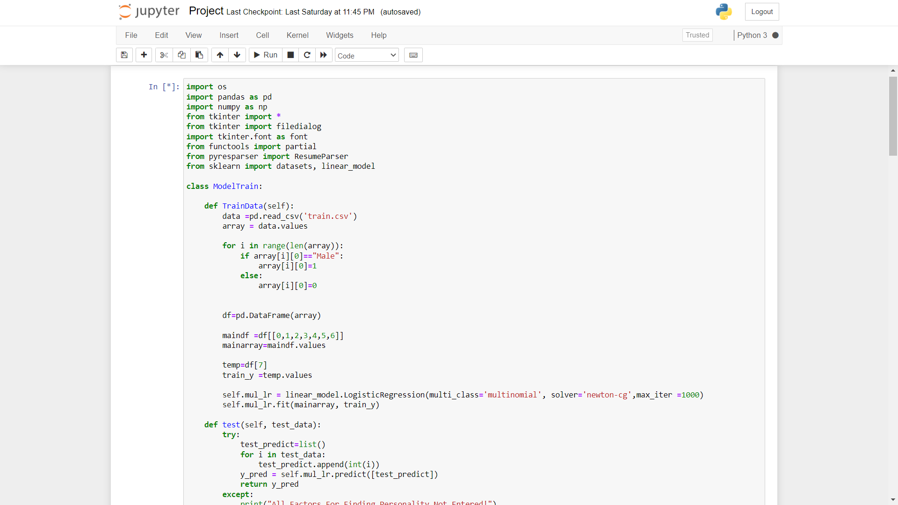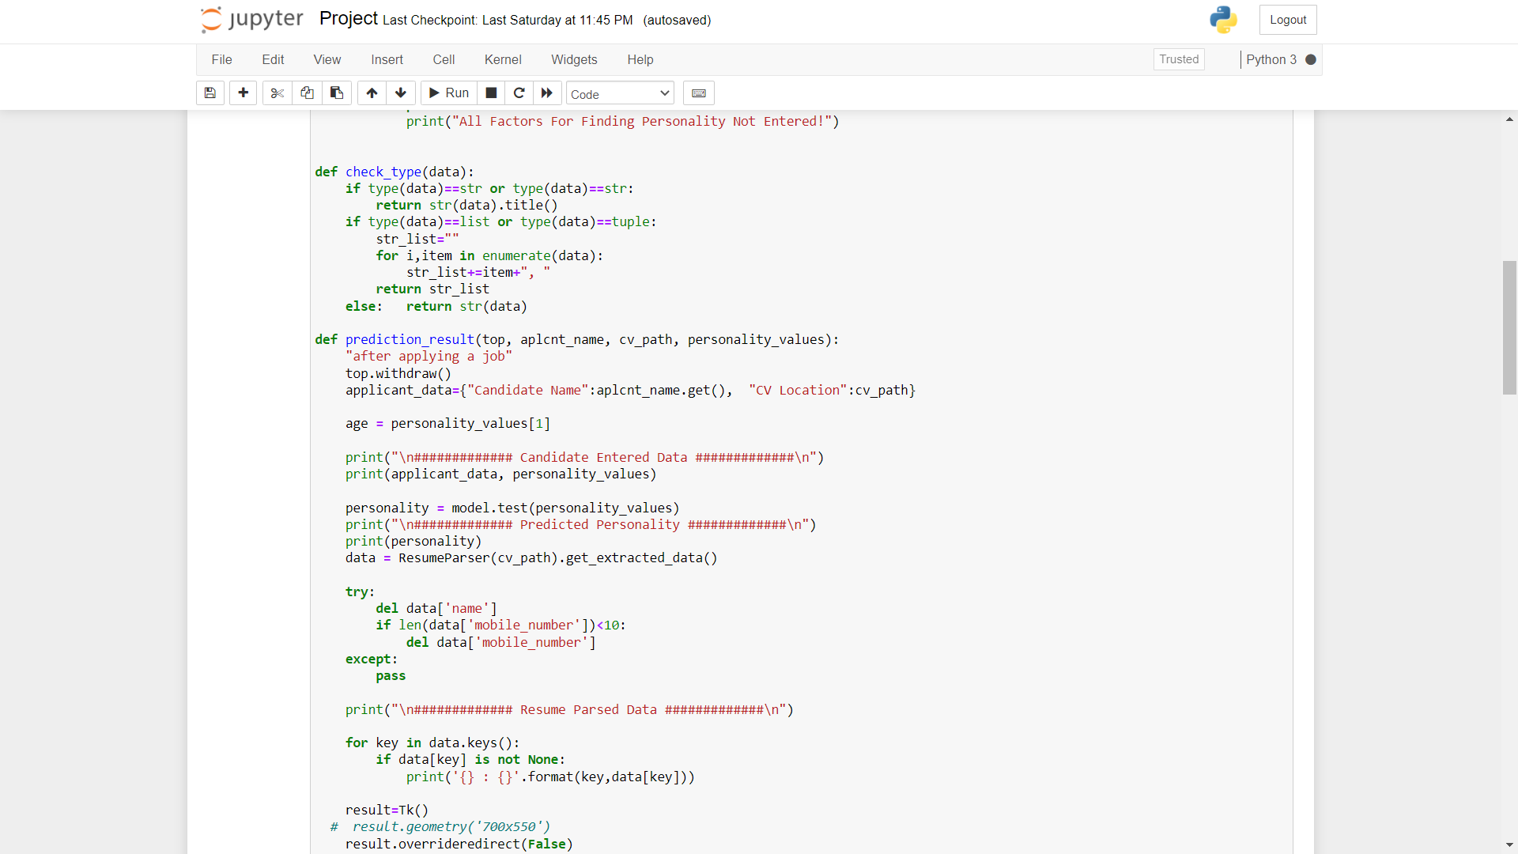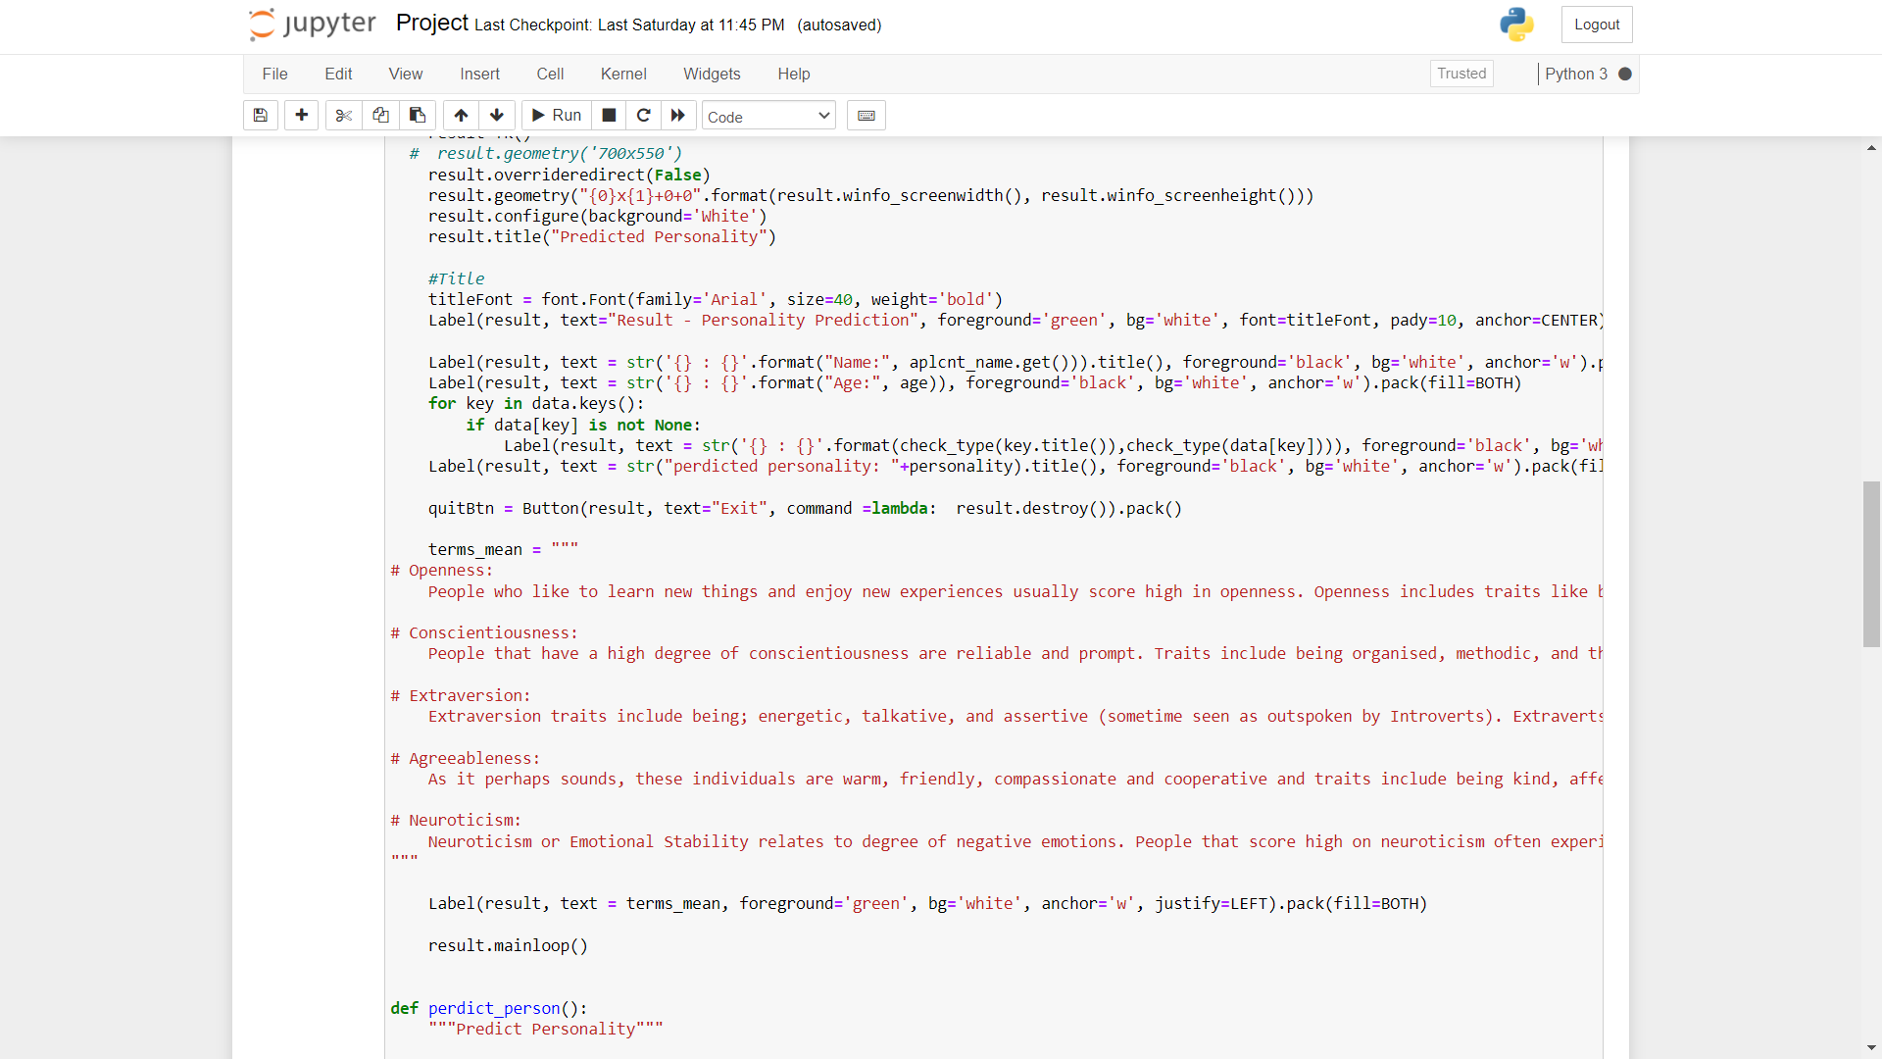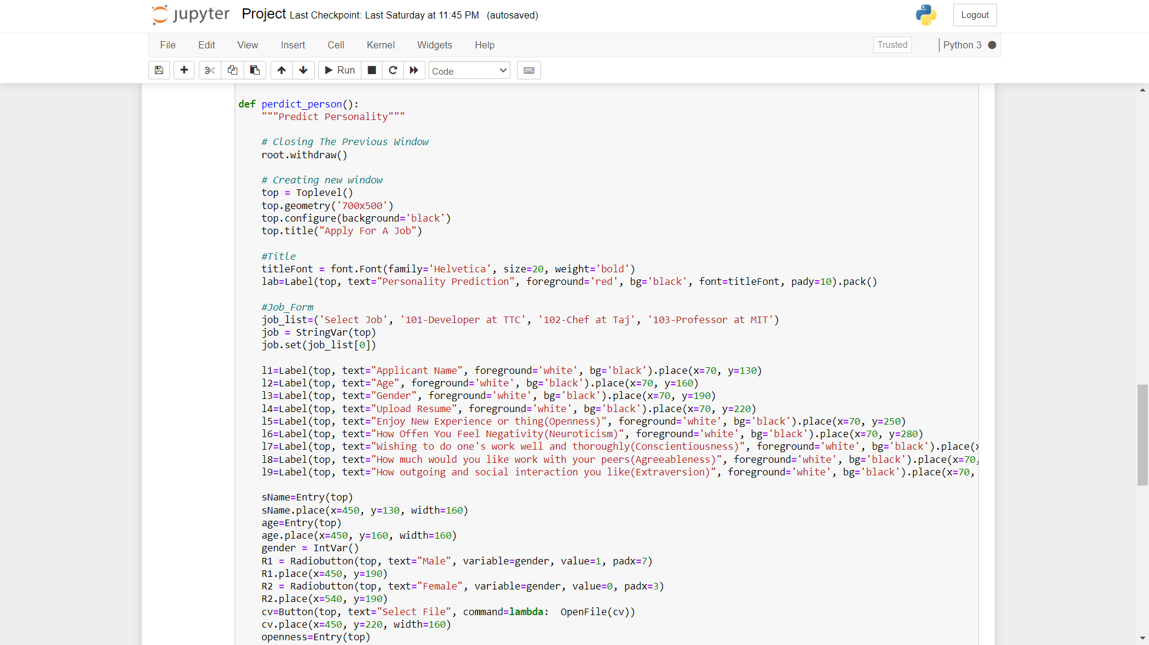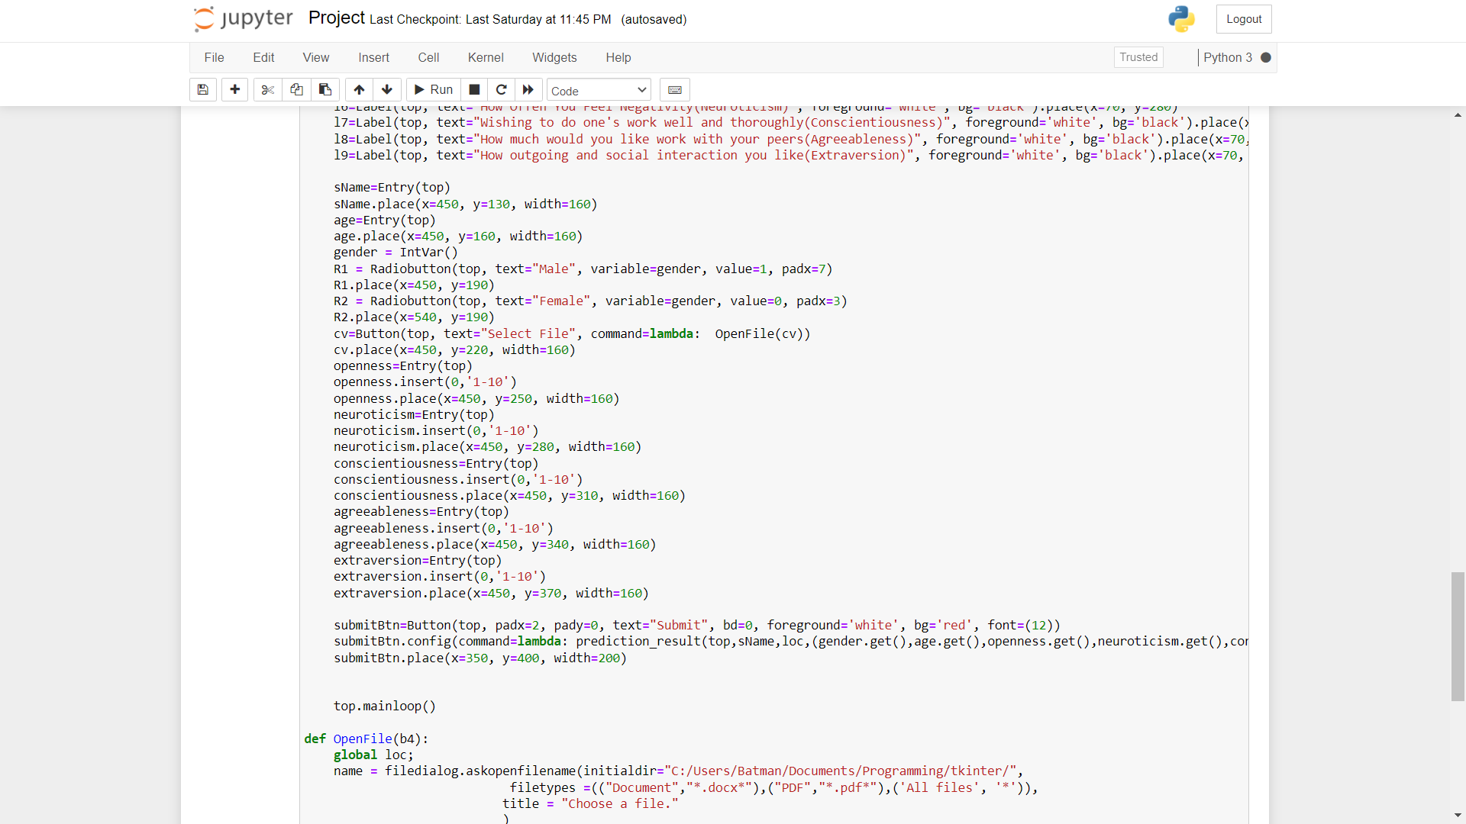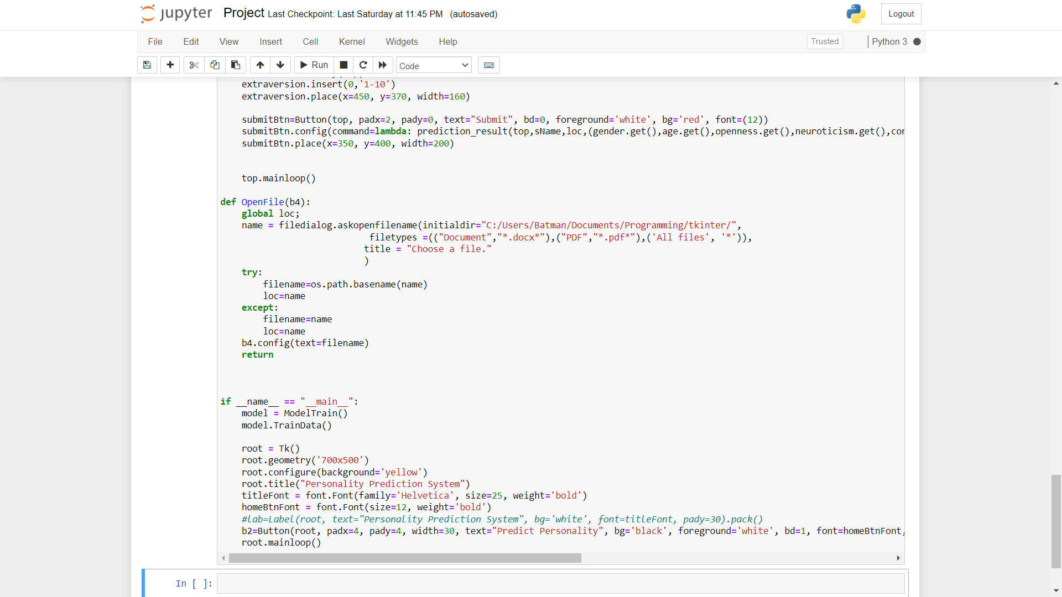

6.1 Implementation :-
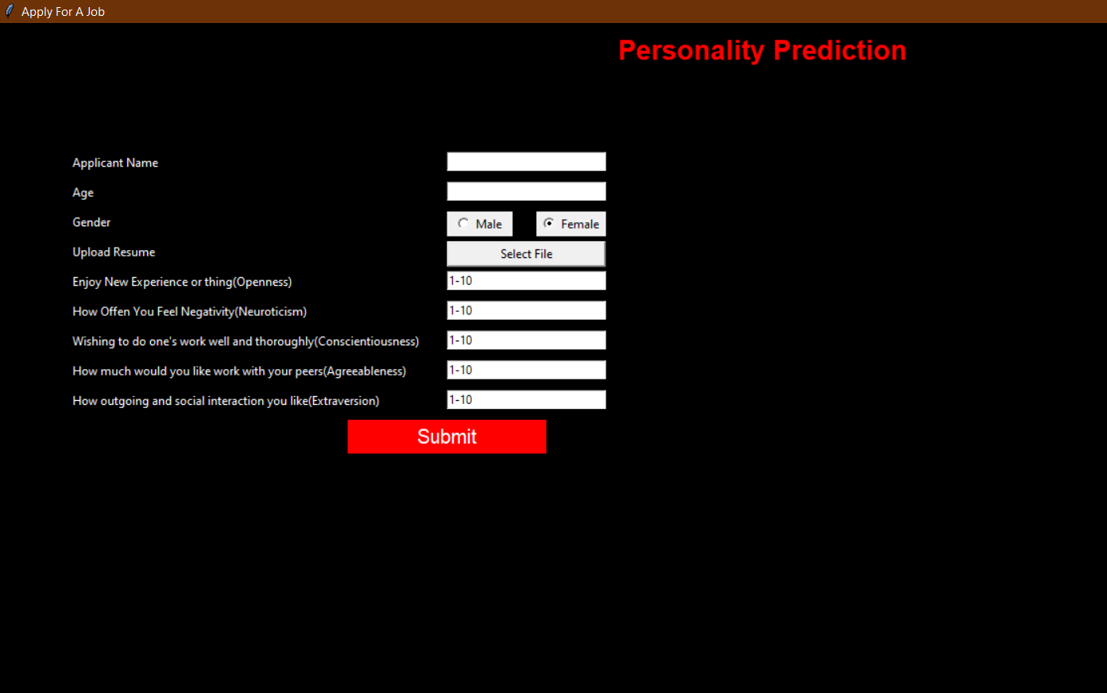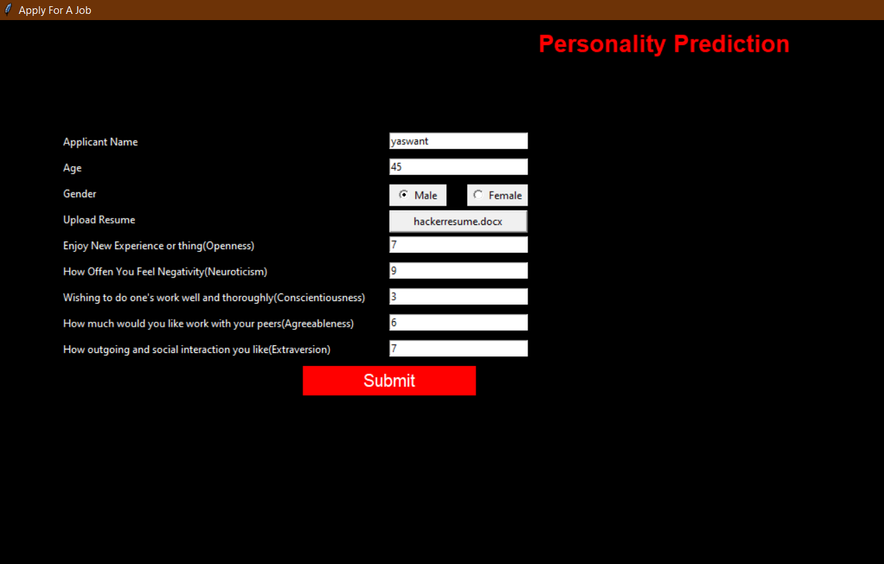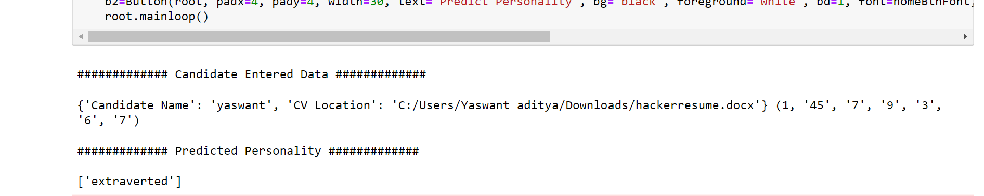

- Bibliography :-
- https://www.irjet.net/archives/V6/i2/IRJET-V6I2343.pdf

- https://nevonprojects.com/personality-prediction-system-through-cv-analysis/

- ijert.org

